
Bandai Namco Amusement America Inc.
1550 Glenlake Avenue, Itasca, IL 60143
https://shop.bandainamco-am.com
Bandai Namco Toys & Collectibles America Inc.
23 Odyssey, Irvine CA 92618
https://www.bandai.com/

THE GUNDAM BASE CHICAGO GRAND OPENING DATE ANNOUNCED
First U.S. GUNDAM BASE Store to Open December 12, 2025 at Fashion Outlets of Chicago, Accompanied by GUNDAM World Tour Pop-Up

FOR IMMEDIATE RELEASE
2 DECEMBER 2025

UNITED STATES - Bandai Namco Amusement America Inc. (“BNAA”) and Bandai Namco Toys & Collectibles America Inc. (“BNTCA”) are thrilled to announce the grand opening of THE GUNDAM BASE CHICAGO, the first official GUNDAM BASE location in the United States. The store will open its doors on Friday, December 12, 2025, at the Fashion Outlets of Chicago in Rosemont, Illinois.

Bringing the world of GUNPLA (GUNDAM plastic models) to life, THE GUNDAM BASE CHICAGO offers an immersive retail and hands-on experience designed for both first-time builders and devoted fans alike.

What Shoppers Can Expect
Visitors can enjoy an engaging experience centered on the core GUNDAM BASE themes: watch, buy, build, and learn. The 3,000-square-foot destination will feature:

- Exclusive GUNPLA Kits and Merchandise — Discover model kits and collectibles available only at THE GUNDAM BASE locations worldwide.
- GUNDAM CARD GAME — The popular trading card game will be available for purchase.
- Play Area — A dedicated zone where players can gather to collect and compete in in-store events.
- Exhibit Displays — Showcases of iconic GUNDAM models and dioramas highlighting artistry and creativity.
- Six-Foot-Tall GUNDAM Statue — A must-see photo opportunity for visitors.
- Limited-Edition Promotional Items — Special gifts with purchase available while supplies last.

THE GUNDAM BASE POP-UP WORLD TOUR – December 12, 2025 – January 11, 2026
To celebrate the grand opening of The GUNDAM BASE Chicago store, a limited-time pop-up experience will also be located within the Fashion Outlets of Chicago, just steps away from the main store.

The Gundam Base Pop-Up World Tour will offer exclusive items, special GUNPLA displays, and interactive workshops like “Build your own GUNPLA.”

Exclusive items, interactive workshops, and rare displays make this pop-up a must-see for fans visiting Chicago during the holiday season.

World Tour Pre-sale Item
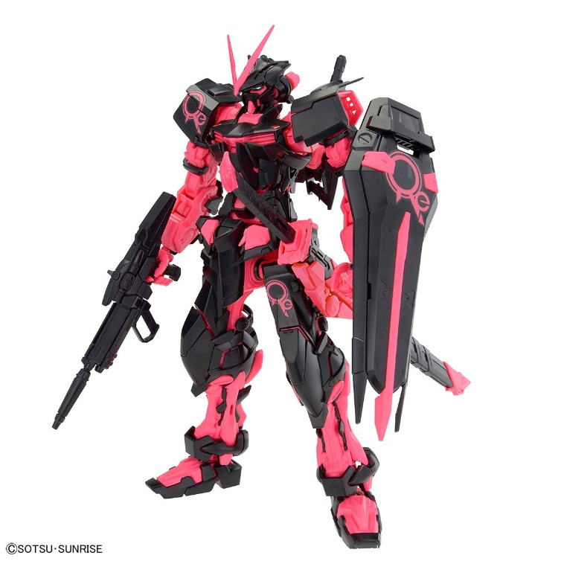
MG 1/100 THE GUNDAM BASE LIMITED GUNDAM ASTRAY RED FRAME [RECIRCULATION COLOR/NEON PINK]

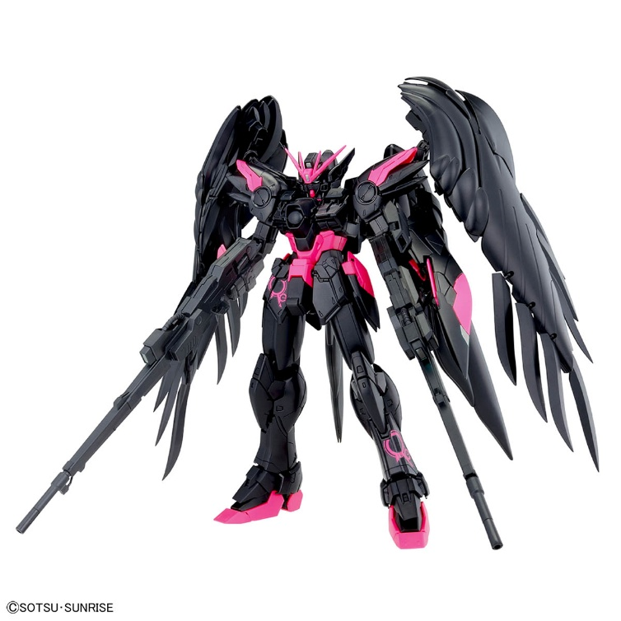
MG 1/100 THE GUNDAM BASE LIMITED WING GUNDAM ZERO EW Ver.Ka [RECIRCULATION COLOR/NEON PINK]

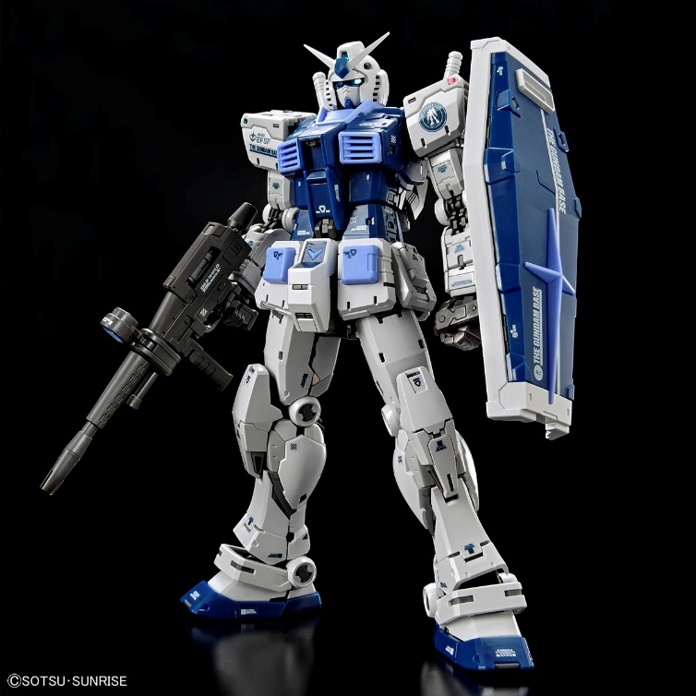
RG 1/144 THE GUNDAM BASE LIMITED RX-78-2 GUNDAM Ver.2.0 [THE GUNDAM BASE COLOR]

"We are thrilled to celebrate the launch of the first GUNDAM BASE in the United States. Our Chicago location will offer an exciting platform to highlight our diverse product lineup and honor the rich history and impact of the GUNDAM franchise,” says John McKenzie, President and CEO of Bandai Namco Amusement America, Inc.
Whether you’re discovering GUNPLA for the first time or expanding your collection, THE GUNDAM BASE CHICAGO promises a one-of-a-kind destination celebrating the creativity, community, and mastery of the GUNDAM universe.

For press inquiries, please contact Shaunda Brooks-Green – sgreen@bandainamco-am.com.

About Mobile Suit GUNDAM SERIES
A series of mecha anime that started from “Mobile Suit Gundam” broadcasted in Japan from 1979. Depicting complicated themes which were unseen in any mecha anime of its time. Gundam has celebrated its 45th anniversary in 2024, make sure to don’t miss out on future updates on this long running series.

Follow us on social media for all GUNDAM news:
Facebook: https://www.facebook.com/ GUNDAMInfoNA
Instagram: https://www.instagram.com/gundaminfona/
Twitter/X: https://x.com/GUNDAMInfoNA

About THE GUNDAM BASE
THE GUNDAM BASE is an official GUNPLA facility for GUNPLA fans around the world. Aiming to expand the GUNPLA business, the company opened official GUNPLA stores in Korea in 2003, Taiwan in 2005, Tokyo in 2017, Shanghai in 2018, and Thailand in 2021. Currently, there are 35 stores operated worldwide.

For more information, visit the feature page on Bandai Hobby site: https://global.bandai-hobby.net/en-us/news/02_2705/

Store Information
Store Name | THE GUNDAM BASE CHICAGO
Location | 5220 Fashion Outlets Way Unit #1050, Rosemont, IL 60018
Opening Date | Friday, December 12, 2025
Hours of Operation | Opening Day: 10:00am-9:00pm/CT  M-Sa 10:00am-8:00pm/CT; Su 10:00am-7:00pm/CT  Holiday Hours: https://www.fashionoutletsofchicago.com/hours
Size | 3,000 sq. ft.
Website | https://global.bandai-hobby.net/en-us/news/02_2705/
All other trademarks are the property of their respective owners. ⒸSOTSU・SUNRISE ⒸSOTSU・SUNRISE・MBS Bandai logo: TM & © 2023 Bandai Namco

